THIS WEEK’S
STORIES
WEEKLY
SPORTS
HABERFIELD’S’S

HABERFIELD DEFEATS BURWOOD
Haberfield Public School’s PSSA softball team triumphantly defeated Burwood 16 to 5 at Ashfield Park.

Opening Issue 22/2/16
GUEST WRITERS
CREATED BY
Freya
HABERFIELD PUBLIC SCHOOL
Email: haberfield_p.school@det.nsw.edu.au
Web: www.haberfield-p.schools.nsw.edu.au
HPS Student Journalist Web: http://hpsstudentjournalists.weebly.com
Telephone: (02) 9798 8767

Annalise
Holly
Kaija
Ryan
Joel

DIVE IN PUSH OFF
227 students flooded Ashfield Aquatic Centre for Haberfield Public School’s annual swimming carnival.

HABERFIELD THRASHED SOUTH STRATHFIELD
Haberfield Public School thrashed South Strathfield Public School in a thrilling game of 12 over cricket.

Haberfield defeats Burwood
Kaija, Annalise & Holly Year 6
22/2/16

Haberfield Public School’s PSSA softball team triumphantly defeated Burwood 16 to 5 at Ashfield Park.

In the inaugural PSSA match of 2016, Haberfield’s senior girls’ softball team defeated Burwood 16 to 5 at their home ground of Ashfield Park.
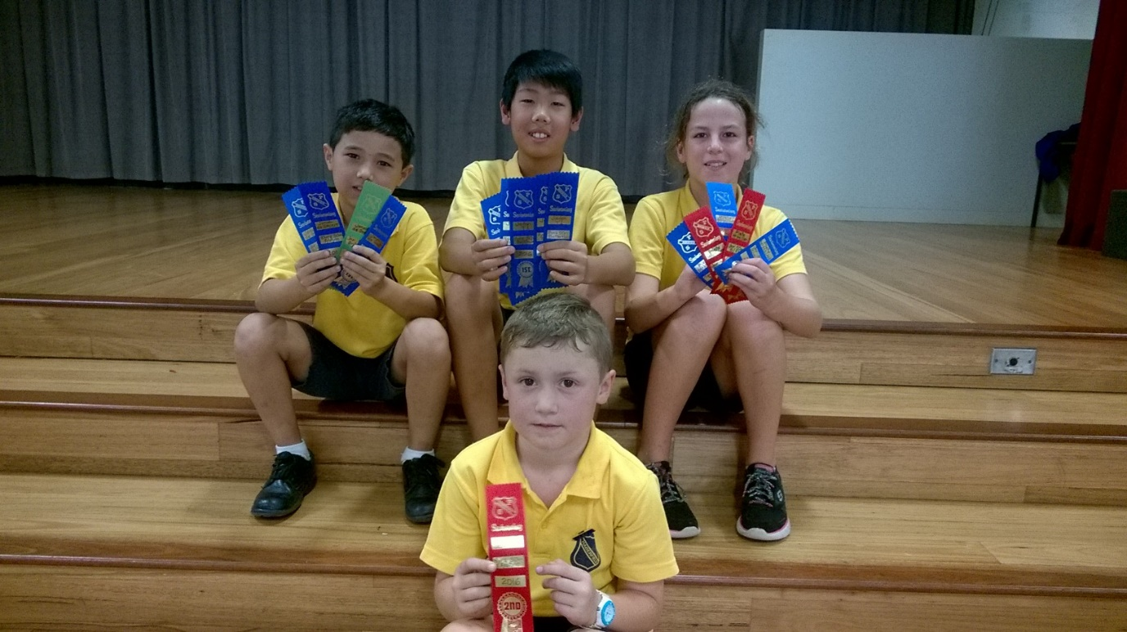
Burwood’s decision to bat first looked set to backfire when Haberfield successfully struck out three of their players before they redeemed themselves with four points at the end of the first innings.
Success for Haberfield swimmers at the 2016 Annual Swimming Carnival. Photograph: Mrs Mussone
Haberfield stepped up to the plate and took the lead in the fast paced game, batting 9 people home in the first innings.
After a few silly errors from both teams in the second innings, Haberfield continued their winning streak and scored 7 home runs, edging out the competition in the first match by 11 points.

It was a fast but good game. Haberfield definitely proved that they could play softball and work as a team. The Senior Girls softball team should be proud with the win.
Both teams should be congratulated for trying their hardest, showing great cooperation and confidence.
Softball is a competitive sport where two teams bat it out to get the most home runs possible. The fielding team is made up of the pitcher, shortstop, first base, second base, third base, catcher, right outfield, left outfield and centre outfield. If you make it to all the bases, plus home base it counts as one point.
This Friday Haberfield will play Croydon Park.

Dive in push off
Freya Year 6
22/2/16

227 students flooded Ashfield Aquatic Centre for Haberfield Public School’s annual swimming carnival.

Students from Year 2 to Year 6 competed against their age peers in freestyle, breaststroke, backstroke, butterfly and the individual medley which is a combination of all four strokes.
Swimmers were literally jumping off their blocks with adrenaline all keen to receive that blue, first place ribbon. The competitors were so eager to race that there was no time for the individual medley.
Senior Girls House Captains’ Kaija, Madeline and Simona all felt their houses were setting a cracking pace and had a chance of winning the overall carnival. The general atmosphere of the swimmers was that of quiet enthusiasm.
Both students and teachers regarded Haberfield Public School’s 2016 annual swimming carnival as a great success.

Haberfield thrashed South Strathfield

Ryan & Joel Year 6
22/2/16

Haberfield Public School thrashed South Strathfield Public School in a thrilling game of 12 over cricket.

In their first match of the season Haberfield’s PSSA Senior Cricket team elected to field in an attempt to put pressure on their opponents, South Strathfield.
Haberfield’s newly formed team opened with bowler, Jackson taking one wicket in the first over. Bowlers Jeean, Lawrence and Ryan followed up taking another 11 wickets leading to some stunning catches by Jackson and Ryan.
South Strathfield’s batters left the field with a decent score but not enough runs to defeat Haberfield.

The Haberfield batters entered the field with 55 runs from wickets. Lawrence and Alexander opened the batting, giving away the only wicket to the South Strathfield bowlers. Even with South Strathfield’s neat bowling, Haberfield’s batters were able to walk away the clear winners, hitting five 4s.
Haberfield Public School’s Senior Cricket team will compete every Friday at 1pm during the season.
If you want to see the fixtures and the ladder go to
http://westernsuburbs.sessazones.com/sports-in-our-zone/cricket/

